FOR IMMEDIATE RELEASE

Powerful Intelligent Stepper Control Module fits into small spaces
Liberty Hill, Texas – October 2018
Texas-based company AccelMotion® today announced the DC2M17 Intelligent Motor Module. It transforms a NEMA17 stepper motor into a complete compact motion-control subsystem.
AccelMotion achieved this compact motion-control subsystem by integrating a powerful but efficient driver with an easy-to-use feature-rich motion controller, configurable general-purpose inputs and outputs, and diagnostic and protective circuits; all of it powered by a single supply input. The DC2M17 provides stepper drive control with 2 Amps of drive current at up to 35V, interoperability with other DC-series controller/drivers allowing up to 32 axes of motion under a single hosts control and language compatibility with products from sister company AMS as well as other AccelMotion products. When attached to a step motor, the resulting motion module reduces wiring and simplifies system layout – because it extends the motor length by only 1.18” (30mm) it fits into tight spaces.
“When adding motion capability to equipment our customers ask for a compact reliable solution, and the DC2M17 provides that, economically” stated David Smith, the CEO of AccelMotion.
Designed for OEM use, the DC2M17 is priced for integration in equipment destined for: laboratory materials handling, packaging, testing, factory automation, and other motion-control applications. An optional aluminum case cover provides protection in tough environments as well as better cooling under higher load.
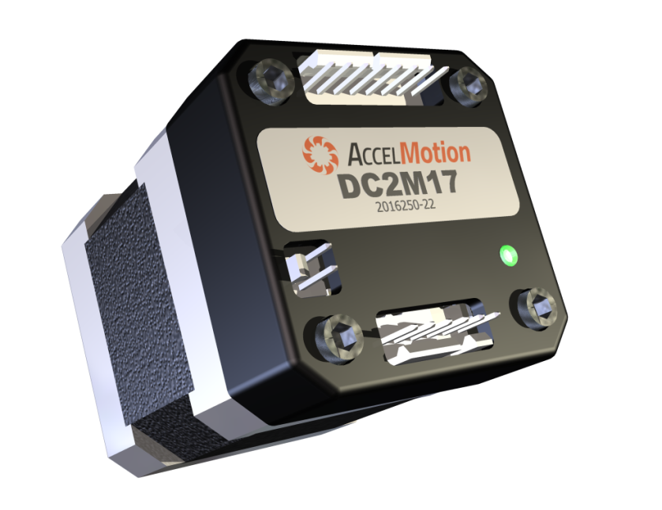
For more information, email the company at: sales@accelmotion.com or call at 512-212-7300.

About AccelMotion
AccelMotion and its sister company Advanced Micro Systems/AMS are located in Liberty Hill, Texas, USA. The AMS family of companies has been in the business of motion control subsystems since 1983.

